**HOW TO INSERT TABLE USING DATA VIEW**

1. Simply drag and drop the table to form

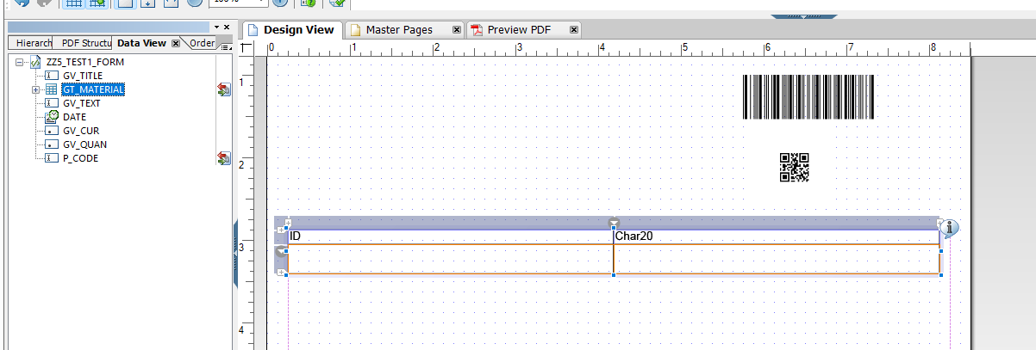

**HOW TO INSERT CUSTOM TABLE**

1. In layout select insert table

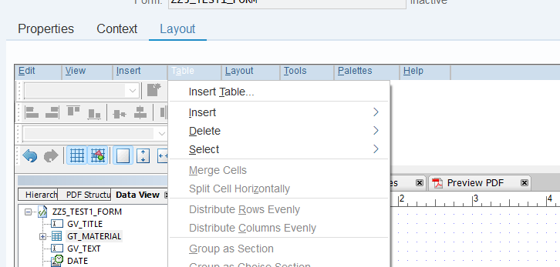

1. Bind the table to custom table

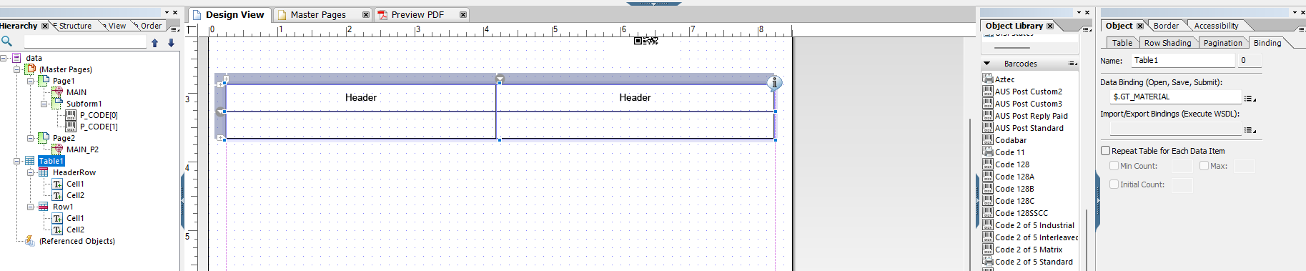

1. Bind the data to custom table row

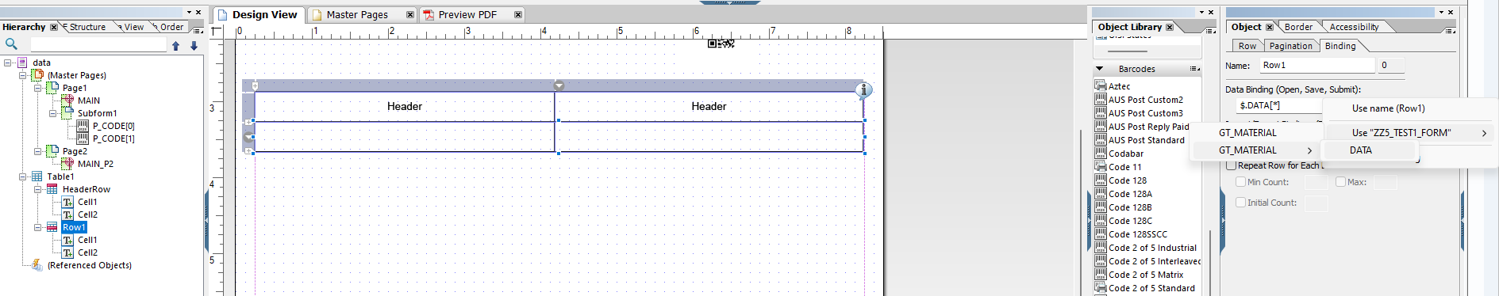

1. Go to data view and bind the fields to columns

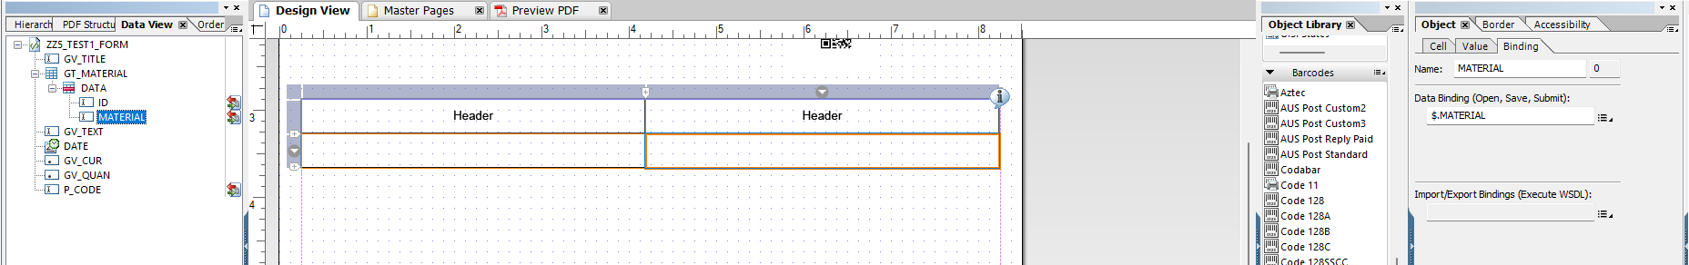

1. For Table and Data row make sure that this is configured

* Table

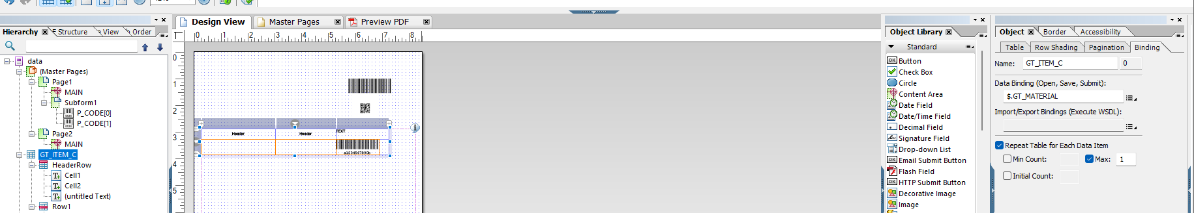

* Table Row

